Unit 10: Correlation between Systolic and Diastolic Blood Pressure
Pearson's correlation was used to examine the relationship between systolic and diastolic blood pressure. The analysis identified a strong positive correlation, r(208) = 0.847, p < 0.001, 95% CI [0.804, 0.881]. This indicates that higher systolic blood pressure values tended to be associated with higher diastolic blood pressure values.
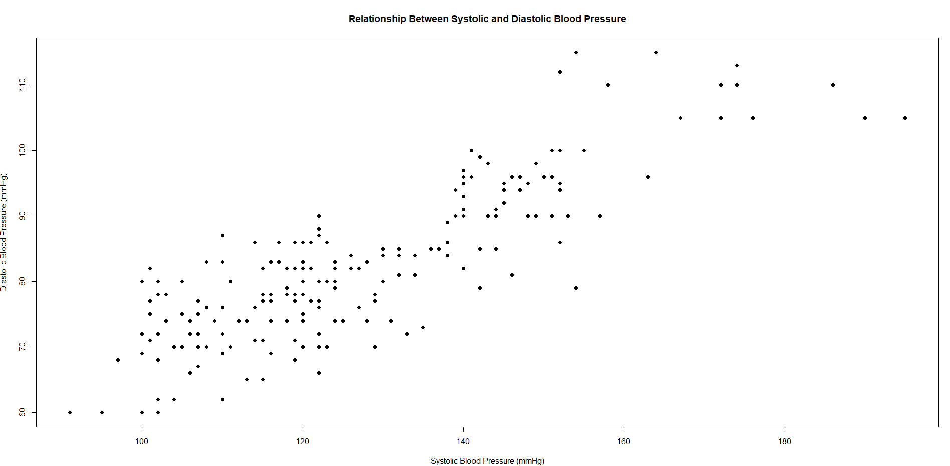
The scatter plot provides a visual representation of this relationship. The points show a clear upward pattern, supporting the correlation analysis and indicating that diastolic blood pressure generally increases as systolic blood pressure increases. Although the relationship is strong and statistically significant, correlation does not demonstrate causation; therefore, these results show an association between the two variables rather than evidence that one causes the other.

Reflection: This activity demonstrated how correlation analysis and scatter plots can be used together to investigate the relationship between two continuous variables. The correlation coefficient provided information about the strength and direction of the association, while the scatter plot allowed the relationship to be examined visually.

